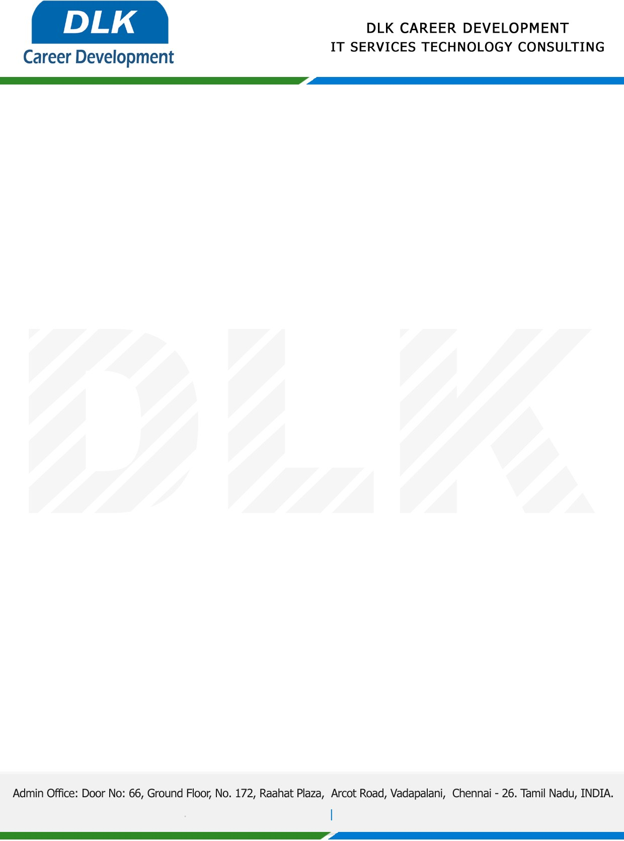

Date: 03 / January / 2022

**To**

Department of MCA ([Computer Application),](https://www.cseindia.org/)

Head of Department,

Vels University, Chennai - 600117.

**Sub: Letter of Project Acceptance**

This is to certify that **Mr. Harish R (REG NO:** **21304131)** that final year student of has accepted his Project Work duration from **4th January 2023** to **1st May 2023** under the domain **“Java”.** During the internship, all information and data collected from you should be kept confidential.

**Topic: A verifiable and fair attribute based proxy Re- encryption scheme for Data sharing in clouds**.

We appreciate your interest in **DLK CAREER DEVELOPMENT**

